**How to update the Regional Economic Dashboard**

**Overview**

In order to update the Regional Economic Dashboard with new data, please navigate to the folder “www”, where all the files of interest reside:

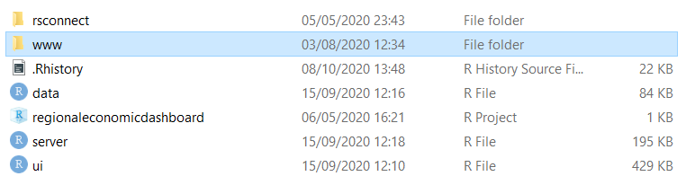

Once there, you will find the four folders that contain all the data underlying the application. These are: “enterprise_region_areas”, “local_authorities”, “regions” and “rural_and_urban”. These folders contain CSV files that house the data for the 4 tabs:

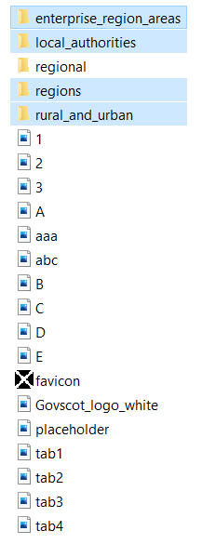

One should note that the file named “regional” contains data for the map, and the content in there should not be modified.

The process of updating every tab is the same, therefore here shown is only how to update the Local Authorities tab.

In the “local_authorities” folder, one will see the following:

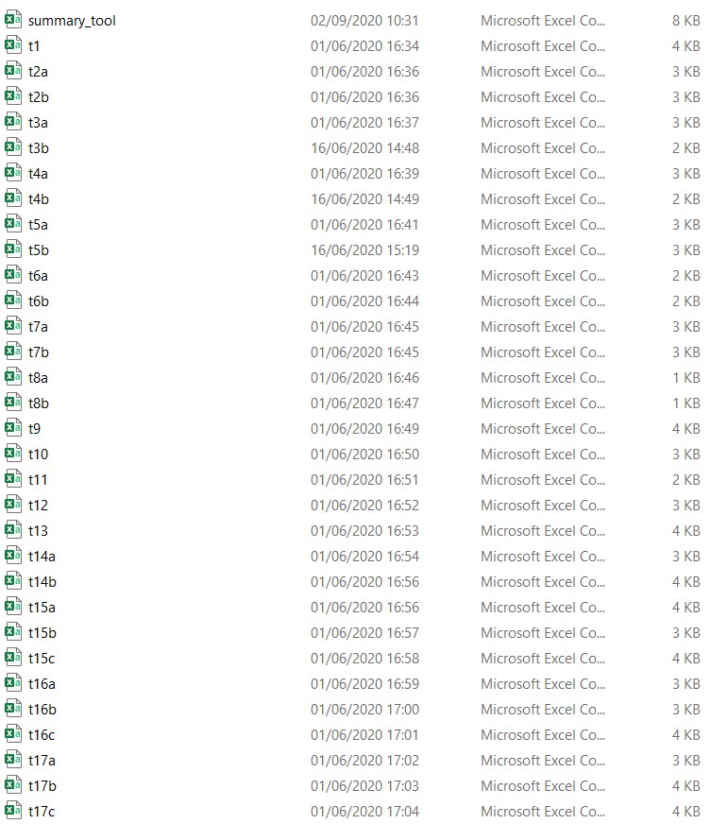

**Updating the Summary Tool**

The CSV file titled “summary_tool”, contains data for the section under heading “Full data set”, titled “Summary Tool”. This is how the data visualization looks like for that CSV file:

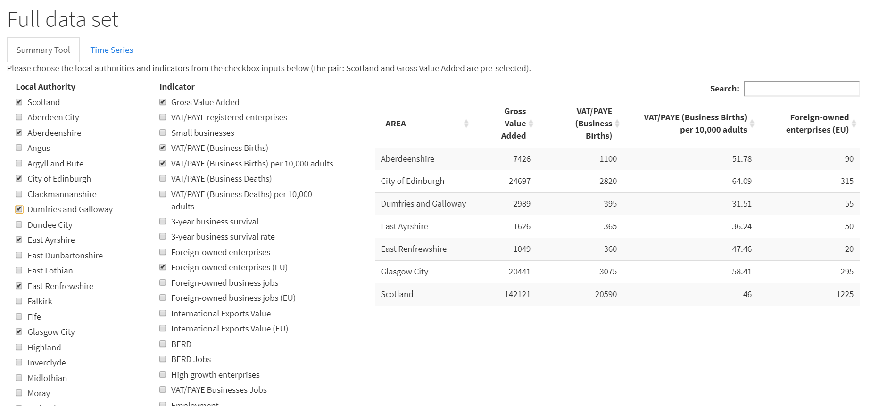

In the “summary_tool” CSV file one will see the following:

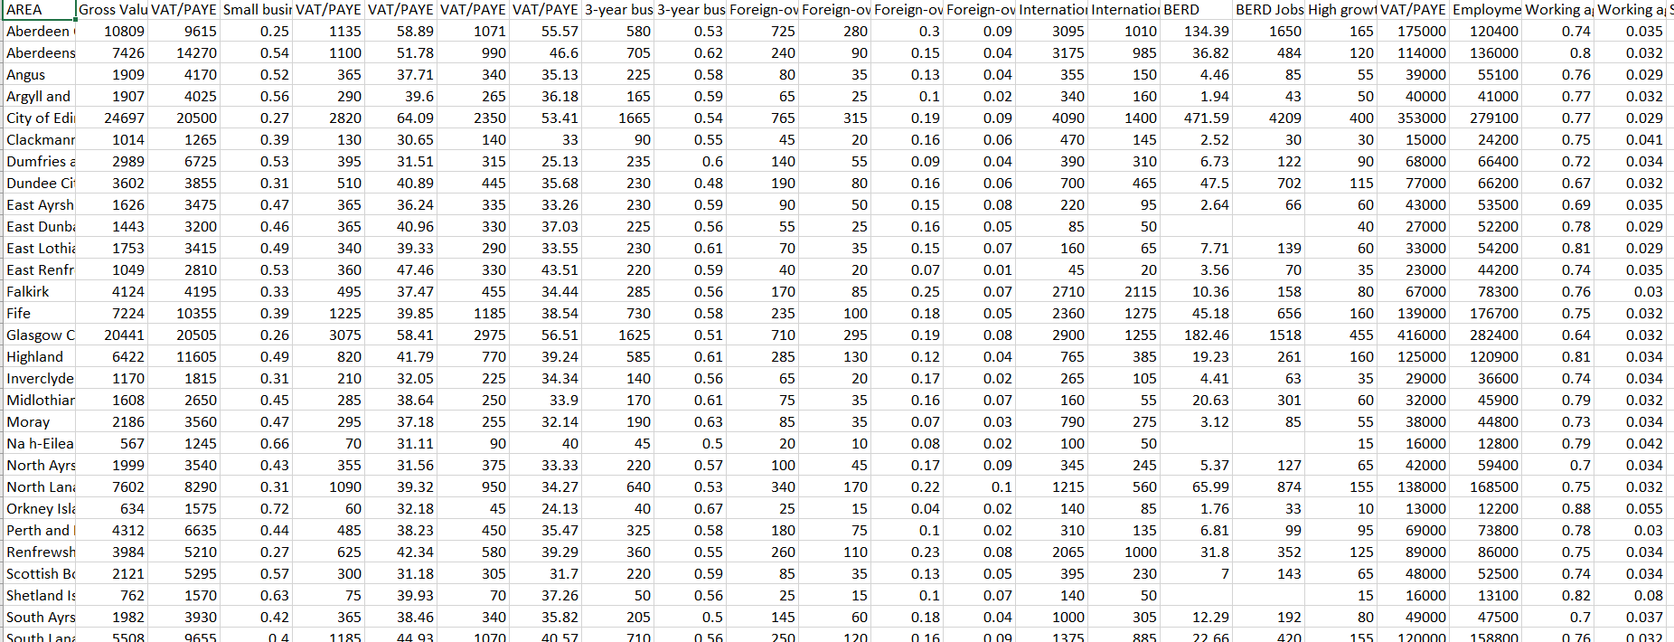

Cases represent local authorities and columns represent indicators.

This is for the latest available year.

In order to replace the data for new year, simply replace the figures with the relevant ones.

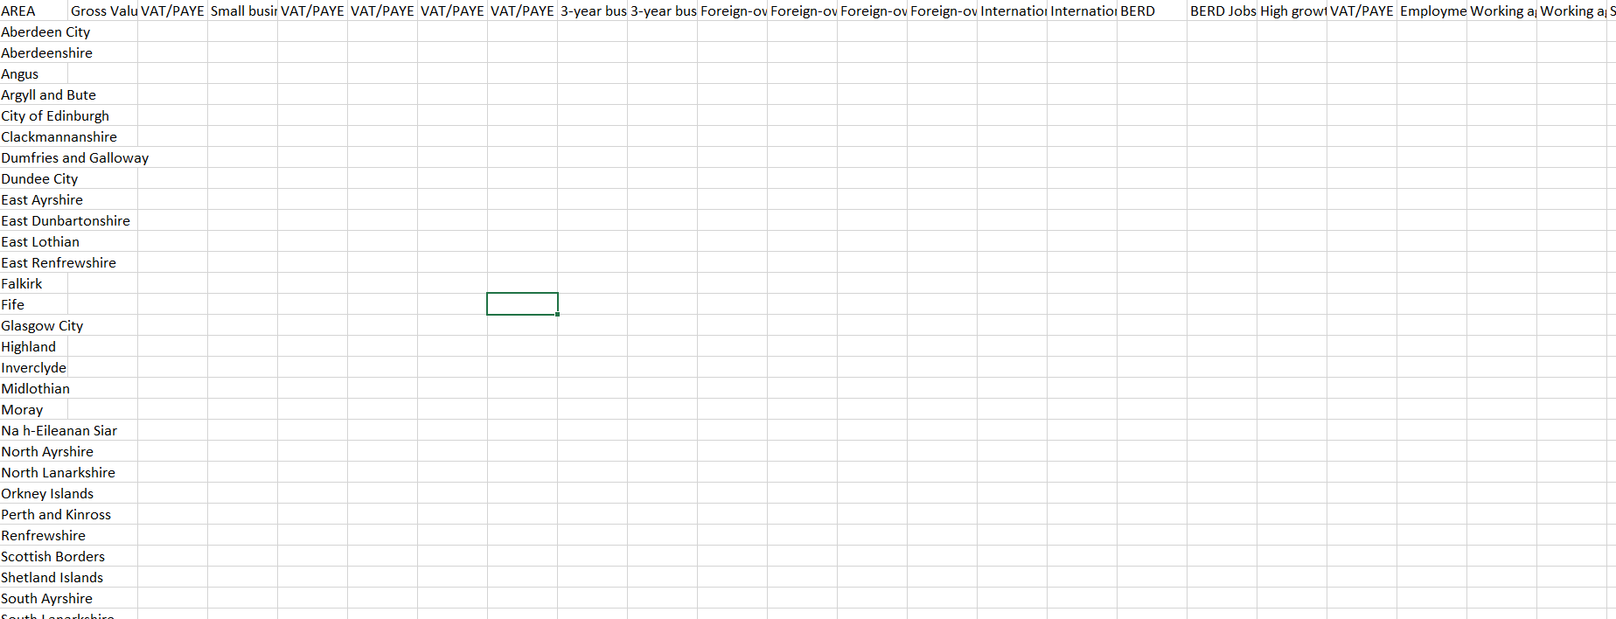

**Updating the rest of the Dashboard**

The data for all the other data visualisations excluding the summary tool is housed in the other files, where each indicator has a dedicated csv file.

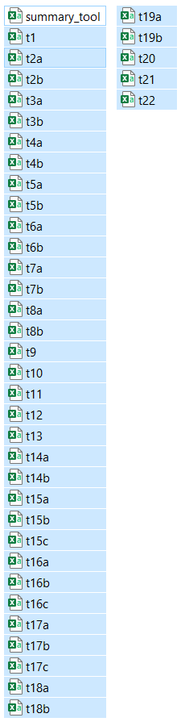

In order to know which indicator is placed where one would require the Excel spreadsheet “Local Economic Statistic database” where a legend is:

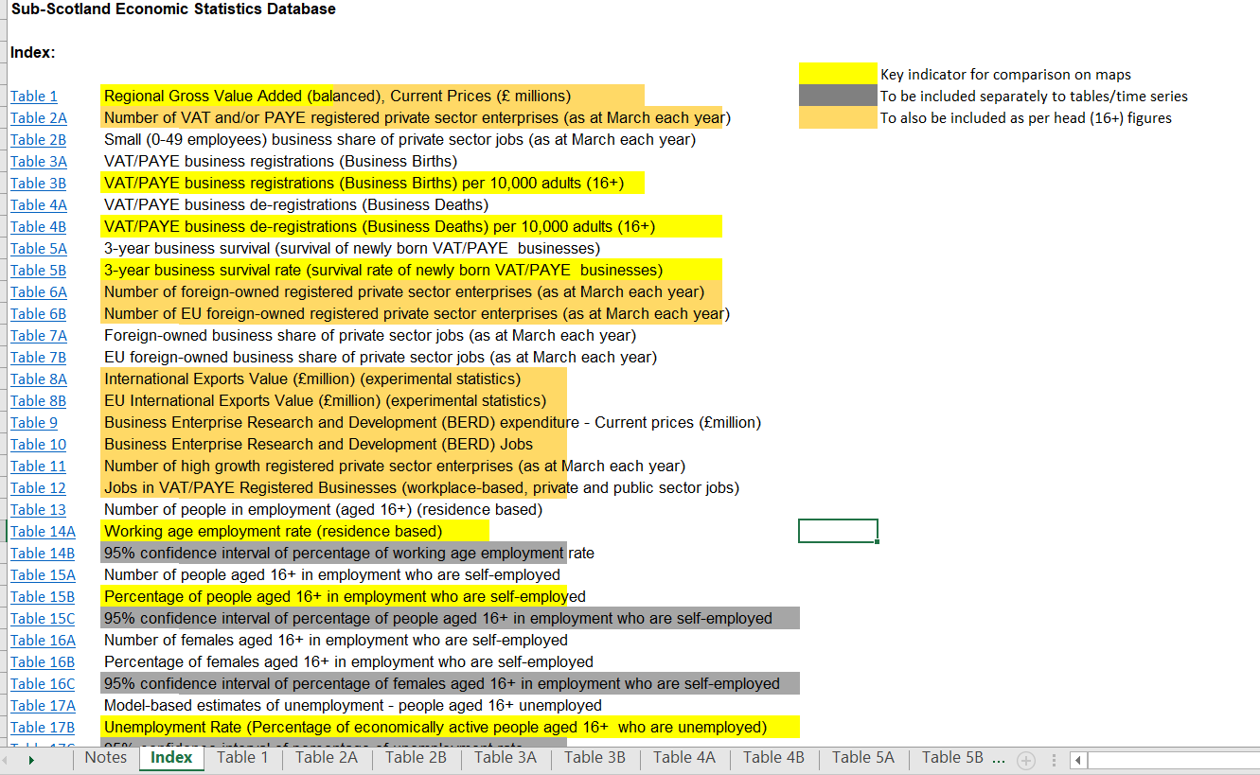

Updating every table requires identical process, hence only an example of updating t1 is provided:

In file “t1”, one would see the following:

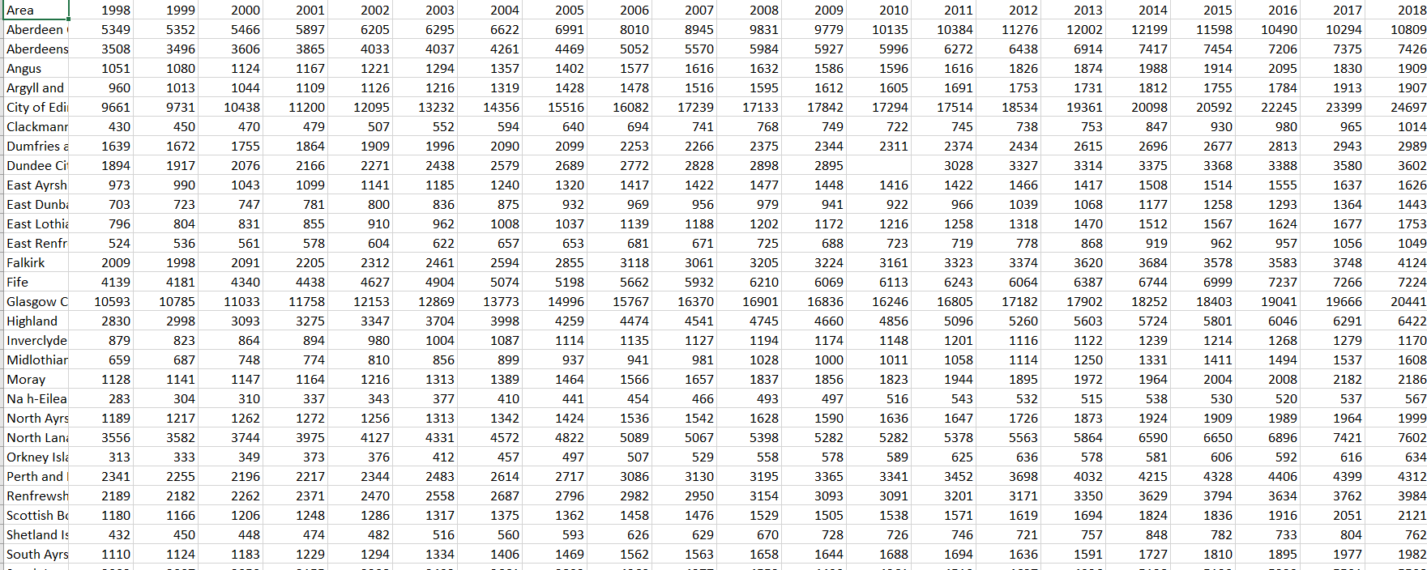

“t1” contains annual data for all local authorities for Gross Value Added.

In order to update it, please append the table with a column for the next year.

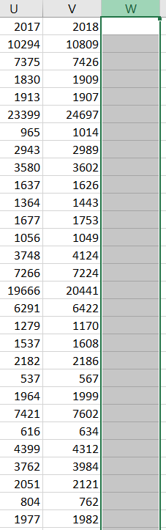 🡪 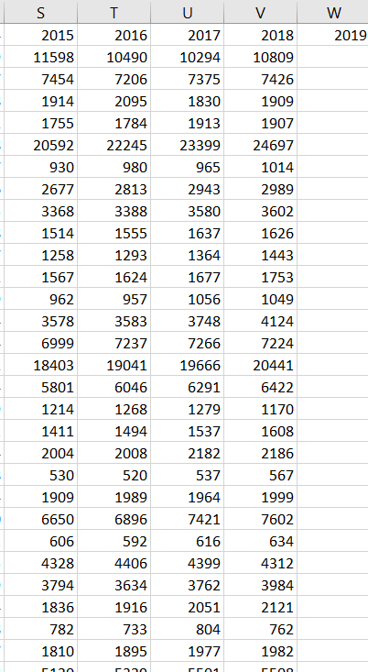

Next repeat the process for all the other indicators and the entire process for all 4 tables.

Should you have any questions, please do not hesitate to get in touch:

szymkowski.k@gmail.com